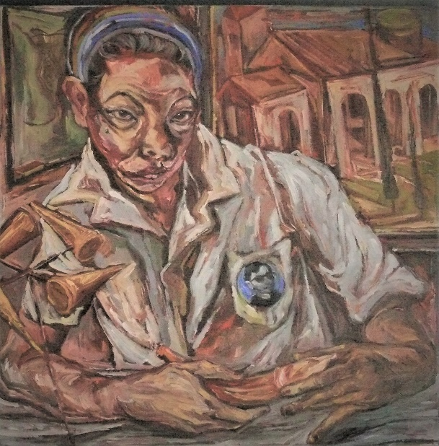

*Melvin Culaba*

“Ang Taray”, 2010.

Oil on canvas.

24” X 24”